**Paper1.1.Explain Ideal low pass filter and effect of different cutoff frequencies.**

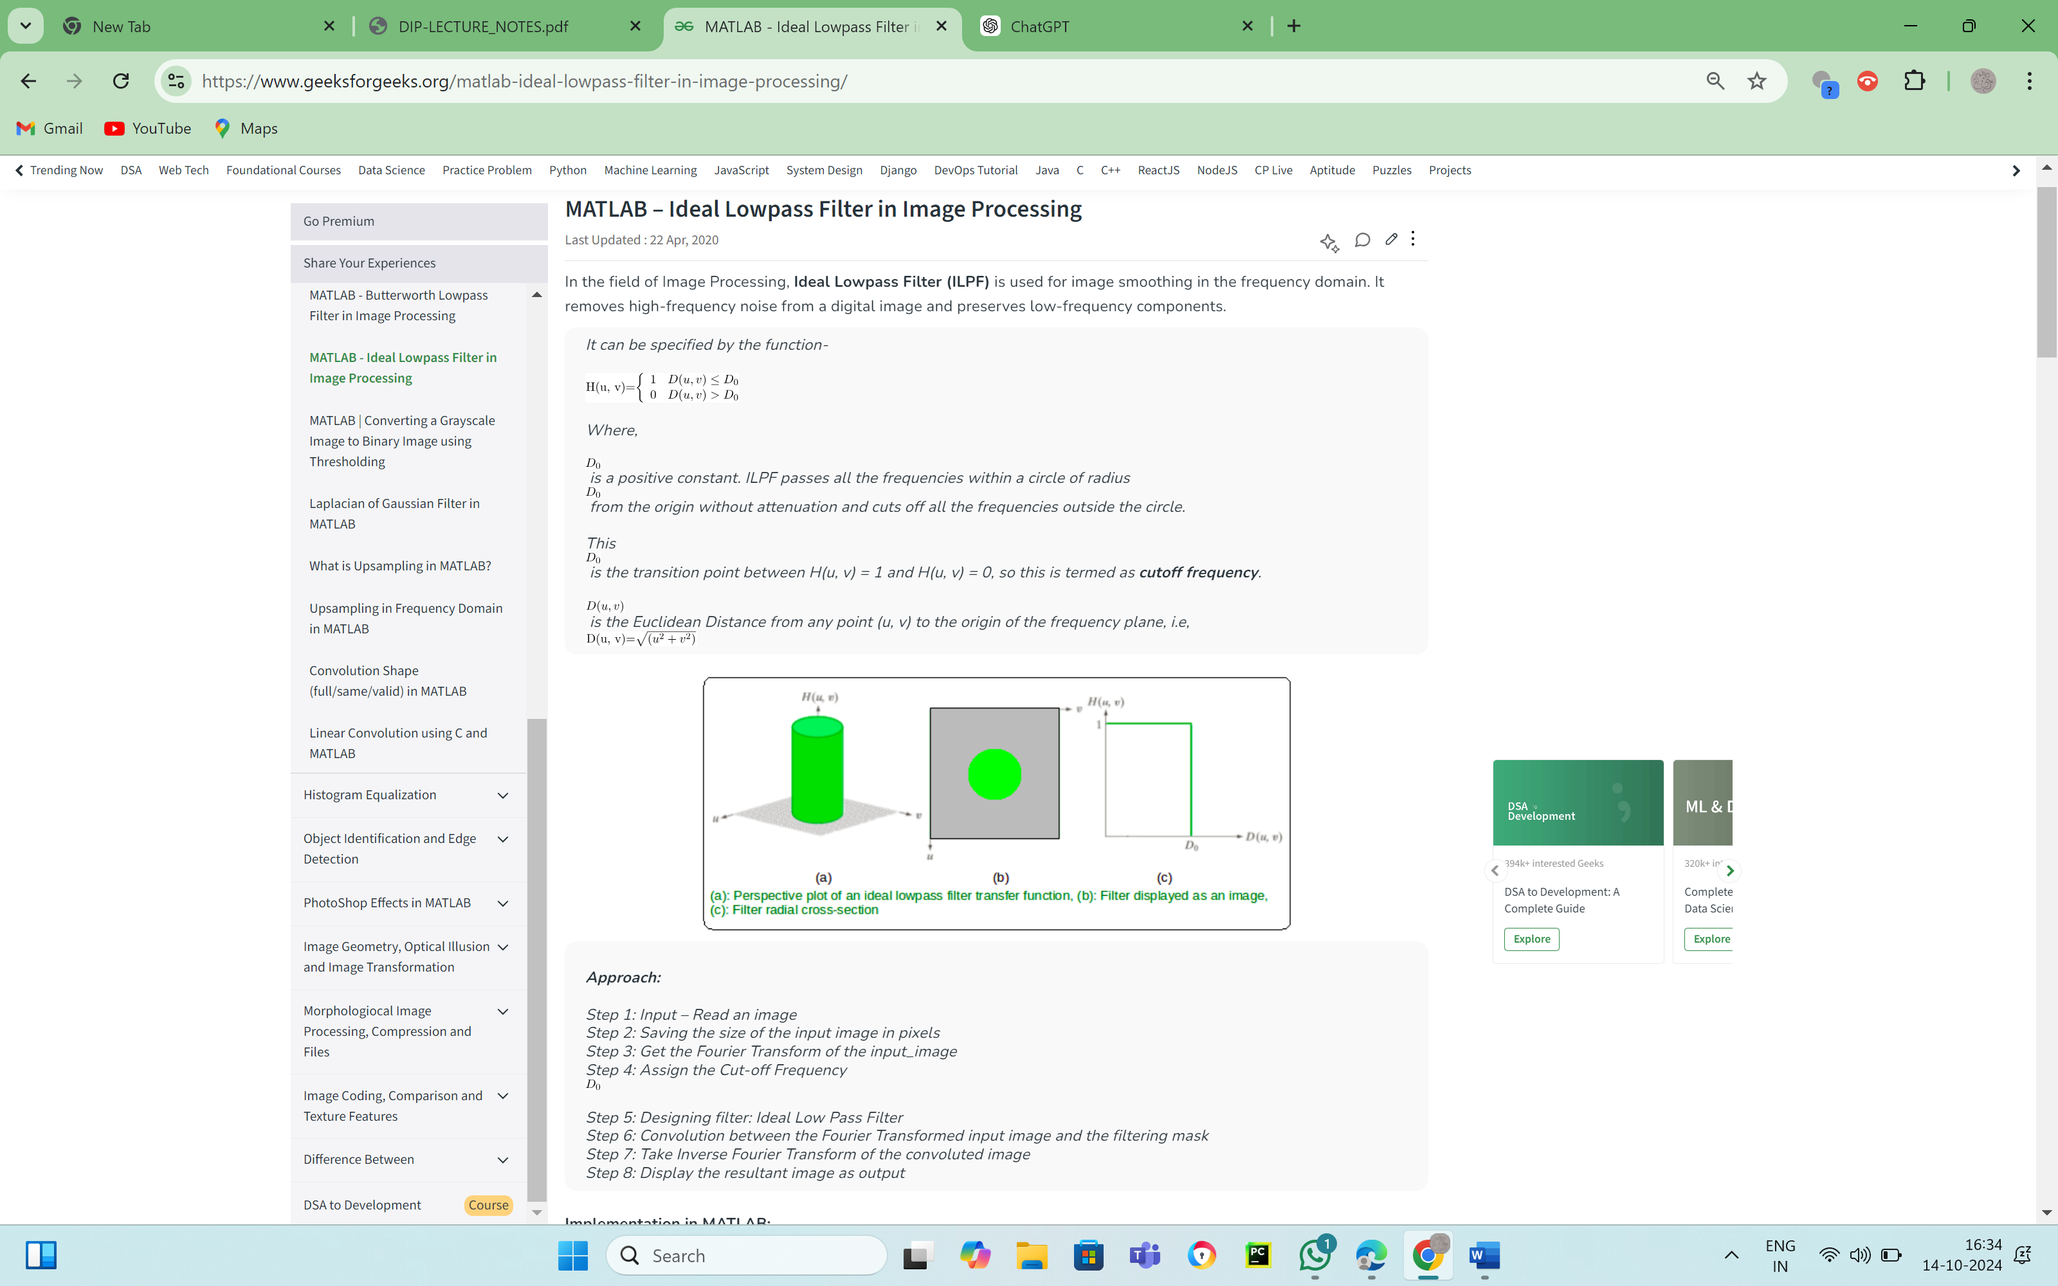

Effect of Different Cutoff Frequencies:

* Low Cutoff Frequency (Small D0D_0D0​):
  + A low cutoff frequency means that only the very low-frequency components are preserved, and most high-frequency information (edges, fine details) is removed.
  + Effect: The image becomes very smooth, but it loses significant detail and may appear blurry.
* High Cutoff Frequency (Large D0D_0D0​):
  + A high cutoff frequency allows more high-frequency components to pass through, retaining more detail and edges.
  + Effect: The image is only slightly smoothed, with fine details mostly preserved. However, this might not sufficiently reduce noise.
* Very High Cutoff Frequency (Extremely Large D0D_0D0​):
  + If D0D_0D0​ is too large, the filter behaves similarly to no filter at all, allowing nearly all frequencies to pass through.
  + Effect: Minimal to no filtering, meaning the original image's details and noise are fully preserved.

**Paper2.2.What is meant by image enhancement? Why it is needed?**

Image enhancement refers to the process of improving the visual appearance or quality of an image to make it more suitable for a specific task or application. The goal of image enhancement is to accentuate or clarify certain features in an image, making them more visible and easier to analyze or interpret. This can involve enhancing the contrast, brightness, sharpness, or removing noise and artifacts from the image.

Why Image Enhancement is Needed:

1. Improving Image Quality:
   * Images are often degraded by noise, poor lighting, motion blur, or low resolution. Enhancement techniques improve image quality by correcting these imperfections.
   * For example, an underexposed photo can have its brightness and contrast adjusted to make it clearer.
2. Highlighting Important Features:
   * Enhancement helps emphasize certain details or features in an image that might otherwise be difficult to see, such as edges, textures, or specific colors.
   * This is especially useful in medical imaging (e.g., X-rays, MRIs), satellite images, or microscopic images where important details may be subtle.
3. Facilitating Better Visual Interpretation:
   * Enhanced images can be more easily interpreted by human observers. For example, increasing contrast or applying sharpening filters helps people identify objects or patterns more clearly.
   * In tasks such as object recognition, face detection, or vehicle identification in surveillance, image enhancement plays a critical role.
4. Preprocessing for Computer Vision and Image Analysis:
   * Image enhancement is often a preprocessing step for computer vision algorithms, such as edge detection, object tracking, or image segmentation.
   * Enhancing images ensures that features of interest are well-defined, leading to better performance in automated systems.
5. Aiding in Feature Extraction:
   * Certain algorithms, like those used in machine learning or deep learning, perform better when the images are of high quality and the features are well-defined. Enhancement techniques can improve the clarity of features, like edges or textures, making them easier to extract.
6. Recovering Information from Degraded Images:
   * In some cases, images might be captured in less-than-ideal conditions, such as low light, fog, or motion blur. Enhancement techniques can recover lost information and improve clarity, such as in forensics, astronomy, or historical document restoration.
7. Better Aesthetic Appeal:
   * In photography, digital art, or video, image enhancement is used to improve the aesthetic quality of images, making them more appealing to viewers.
   * Enhancements like color correction, sharpening, and dynamic range adjustments are commonly applied in photo editing and graphic design.

**Paper1.4. Explain sharpening frequency domain filters**

Sharpening frequency domain filters are used in image processing to enhance the edges and fine details in an image. In the frequency domain, sharpening is achieved by amplifying the high-frequency components of the image, which correspond to rapid changes in intensity, such as edges and fine textures. This process brings out the details and makes the image appear crisper and clearer.

Understanding Frequency Domain Filtering:

In frequency domain filtering, an image is transformed from the spatial domain (pixel values) into the frequency domain using the Fourier Transform. In the frequency domain:

* Low frequencies correspond to the slow variations in intensity (smooth areas).
* High frequencies correspond to the rapid variations (edges and fine details).

Sharpening filters in the frequency domain enhance high frequencies while keeping the low frequencies relatively unchanged or attenuated.

Steps in Frequency Domain Filtering:

1. Fourier Transform:
   * Convert the image from the spatial domain to the frequency domain using the Discrete Fourier Transform (DFT).
   * The Fourier Transform decomposes the image into its frequency components.
2. Apply the Filter:
   * Once the image is in the frequency domain, a sharpening filter is applied. This filter enhances the high-frequency components.
3. Inverse Fourier Transform:
   * After applying the sharpening filter, the inverse Fourier Transform is performed to convert the filtered image back to the spatial domain, producing the sharpened image.

Types of Sharpening Filters in the Frequency Domain:

There are several types of sharpening filters that work in the frequency domain by amplifying high frequencies:

1. Ideal High-Pass Filter (IHPF):

* The ideal high-pass filter is a simple filter that passes all frequencies above a certain cutoff frequency and blocks all frequencies below it.
* In the frequency domain, it has a circular shape with a sharp cutoff, allowing only high frequencies to pass.

Filter function:

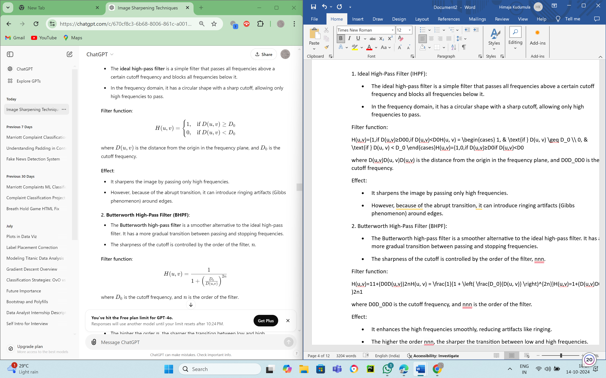where D(u,v)D(u, v)D(u,v) is the distance from the origin in the frequency plane, and D0 is the cutoff frequency.

Effect:

* It sharpens the image by passing only high frequencies.
* However, because of the abrupt transition, it can introduce ringing artifacts (Gibbs phenomenon) around edges.

2. Butterworth High-Pass Filter (BHPF):

* The Butterworth high-pass filter is a smoother alternative to the ideal high-pass filter. It has a more gradual transition between passing and stopping frequencies.
* The sharpness of the cutoff is controlled by the order of the filter, nnn.

Filter function:

​

Where D0​ is the cutoff frequency, and n is the order of the filter.

Effect:

* It enhances the high frequencies smoothly, reducing artifacts like ringing.
* The higher the order nnn, the sharper the transition between low and high frequencies.

3. Gaussian High-Pass Filter (GHPF):

* The Gaussian high-pass filter is another smooth filter with an even more gradual transition compared to the Butterworth filter.
* It follows a Gaussian curve in the frequency domain, meaning there are no sharp transitions.

Filter function:

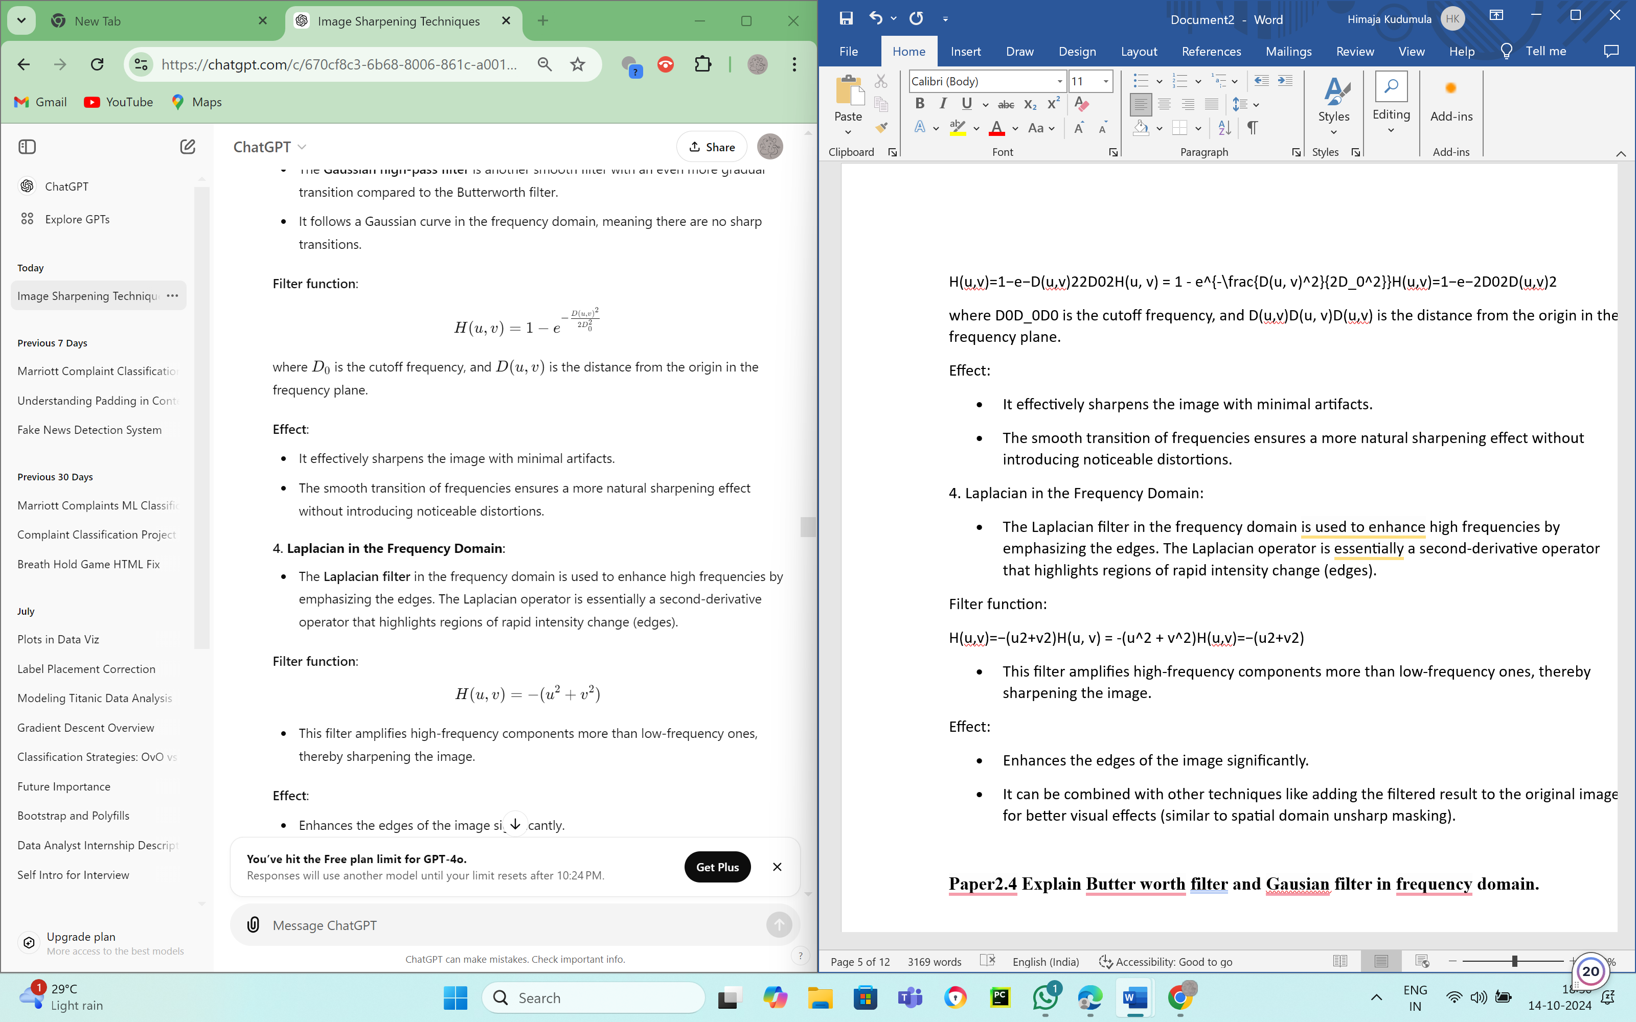 where D0 is the cutoff frequency, and D(u,v) is the distance from the origin in the frequency plane.

Effect:

* It effectively sharpens the image with minimal artifacts.
* The smooth transition of frequencies ensures a more natural sharpening effect without introducing noticeable distortions.

4. Laplacian in the Frequency Domain:

* The Laplacian filter in the frequency domain is used to enhance high frequencies by emphasizing the edges. The Laplacian operator is essentially a second-derivative operator that highlights regions of rapid intensity change (edges).

Filter function:

H(u, v) = -(u^2 + v^2)

* This filter amplifies high-frequency components more than low-frequency ones, thereby sharpening the image.

Effect:

* Enhances the edges of the image significantly.
* It can be combined with other techniques like adding the filtered result to the original image for better visual effects (similar to spatial domain unsharp masking).

**Paper2.4 Explain Butter worth filter and Gausian filter in frequency domain.**

Butterworth and Gaussian filters in the frequency domain are widely used in image processing for smoothing and sharpening. Both are designed to reduce high-frequency noise or preserve image details while making transitions between frequencies smoother than an ideal filter. Let’s break down each filter:

1. Butterworth Filter in the Frequency Domain:

The Butterworth filter is a frequency domain filter that can be used as a low-pass or high-pass filter with a smooth transition between the passband and stopband, unlike an ideal filter, which has a sharp cutoff. The Butterworth filter provides a gradual attenuation of frequencies, making it less likely to introduce artifacts like ringing.

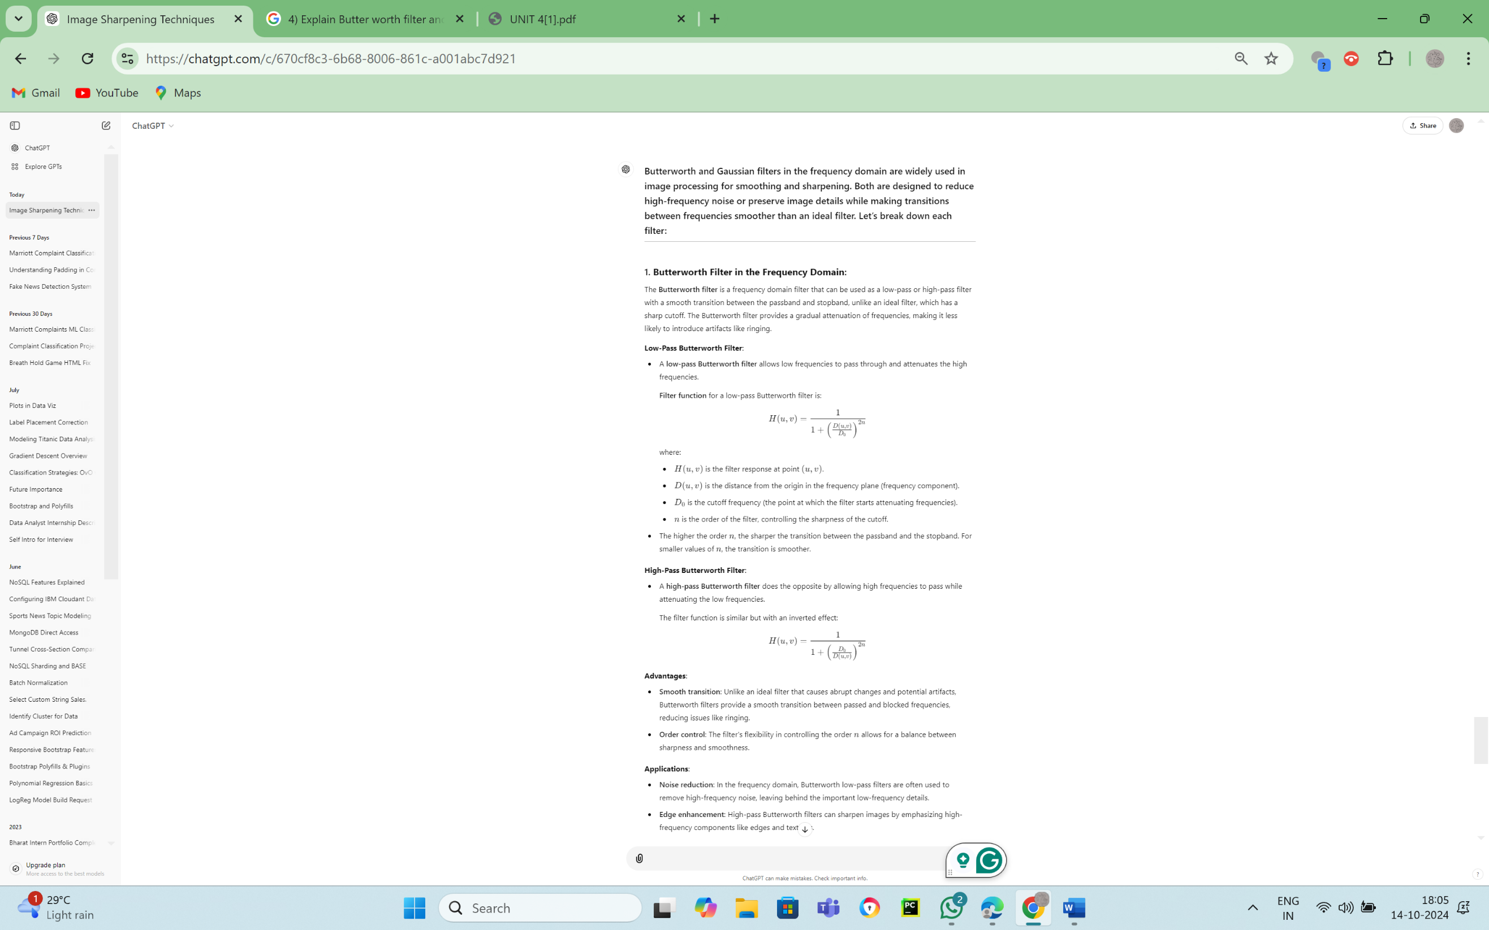

Advantages:

* Smooth transition: Unlike an ideal filter that causes abrupt changes and potential artifacts, Butterworth filters provide a smooth transition between passed and blocked frequencies, reducing issues like ringing.
* Order control: The filter's flexibility in controlling the order nnn allows for a balance between sharpness and smoothness.

Applications:

* Noise reduction: In the frequency domain, Butterworth low-pass filters are often used to remove high-frequency noise, leaving behind the important low-frequency details.
* Edge enhancement: High-pass Butterworth filters can sharpen images by emphasizing high-frequency components like edges and textures.

2. Gaussian Filter in the Frequency Domain:

The Gaussian filter is another commonly used frequency domain filter that is known for its smooth, bell-shaped curve, which ensures very smooth transitions between the passband and stopband without introducing artifacts.

Low-Pass Gaussian Filter:

* A low-pass Gaussian filter allows low frequencies to pass and attenuates high frequencies. It is one of the smoothest filters available and does not produce artifacts like ringing.

Filter function for a low-pass Gaussian filter is:

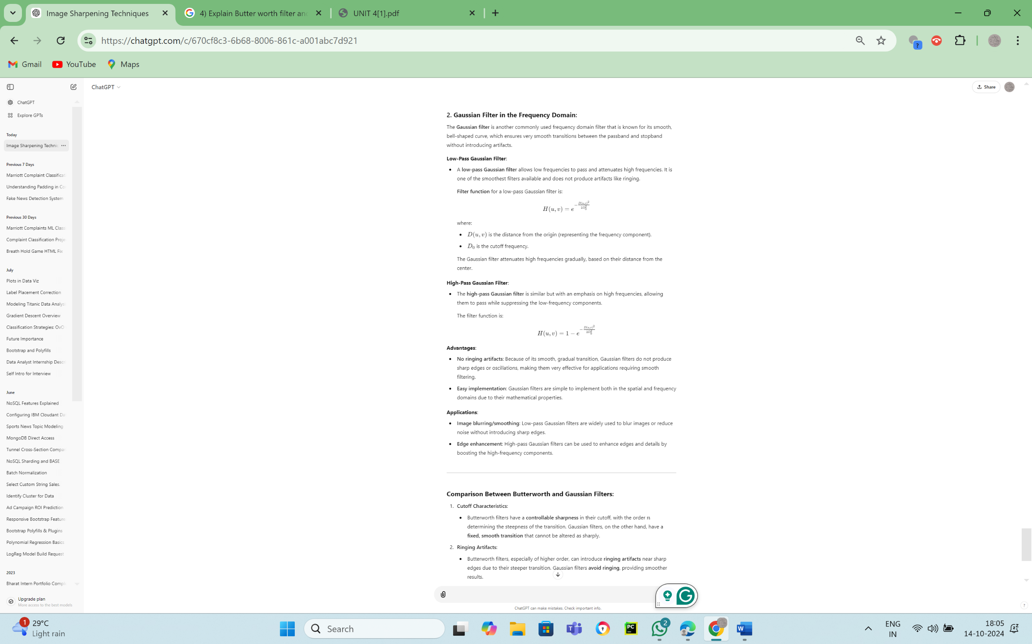

Advantages:

* No ringing artifacts: Because of its smooth, gradual transition, Gaussian filters do not produce sharp edges or oscillations, making them very effective for applications requiring smooth filtering.
* Easy implementation: Gaussian filters are simple to implement both in the spatial and frequency domains due to their mathematical properties.

Applications:

* Image blurring/smoothing: Low-pass Gaussian filters are widely used to blur images or reduce noise without introducing sharp edges.
* Edge enhancement: High-pass Gaussian filters can be used to enhance edges and details by boosting the high-frequency components.

**Paper1.6.a) What is the purpose of a color model?**

A color model is a mathematical system used to represent and describe colors in a standardized way. It defines how colors are encoded, represented, and processed in various digital systems like cameras, monitors, printers, and software applications.

Purpose of a Color Model:

1. Consistent Representation: Color models provide a consistent way of representing colors across different devices, allowing colors to be displayed and interpreted in the same way.
2. Simplifies Color Manipulation: By converting color information into specific channels (e.g., RGB or CMYK), color models make it easier to manipulate, adjust, and process colors for various applications like image editing, printing, and broadcasting.
3. Facilitates Color Conversion: Different devices may use different color models. The color model allows for easy conversion between these models, ensuring accurate color reproduction.
4. Efficient Storage and Transmission: By using an appropriate color model, color data can be efficiently compressed, stored, or transmitted without a significant loss in quality.

Examples of Color Models:

* RGB (Red, Green, Blue): Used for digital screens where colors are produced by mixing different intensities of red, green, and blue light.
* CMYK (Cyan, Magenta, Yellow, Black): Commonly used in printing, where colors are generated by mixing these inks.
* HSV (Hue, Saturation, Value): Used for color editing tasks, where hue represents color, saturation represents intensity, and value represents brightness.
* YUV/YCbCr: Used in video processing and broadcasting, where Y represents luminance (brightness) and U, V (or Cb, Cr) represent chrominance (color information).

**Paper1.6.b) What is color image smoothing? Explain how smoothing is done by neighborhood averaging.**

Color image smoothing is the process of reducing noise and other unwanted details (such as sharp edges or grainy textures) in an image to create a more visually appealing or uniform image. Smoothing techniques are used to reduce small variations in intensity, making the image look softer.

Color Image Smoothing:

* Smoothing involves the use of filters or algorithms that reduce high-frequency components, such as noise or sharp edges, while retaining the overall structure of the image.
* The primary goal is to enhance image quality by reducing visual noise without severely affecting the color or key image features.

Neighborhood Averaging for Smoothing:

One of the simplest and most widely used techniques for image smoothing is neighborhood averaging, also known as mean filtering. It works by replacing each pixel’s value with the average value of its neighboring pixels. This helps in reducing abrupt changes in pixel values, thereby smoothing the image.

How Neighborhood Averaging Works:

1. Define a neighborhood: A window (often a 3x3, 5x5, or 7x7 grid) is centered around each pixel in the image. This window defines the neighboring pixels that will be considered for averaging.
2. Calculate the average:
   * For each pixel, the average value of all the pixels in the defined neighborhood is computed. In a 3x3 window, this means taking the average of the pixel values in the 9 pixels (including the center pixel).
   * The color channels (R, G, B) of the pixel are processed separately in a color image. The averaging process is applied independently to each channel, and then the smoothed color is recombined.
   * Example: For a pixel at position (i,j)(i, j)(i,j), the smoothed value in the red channel is

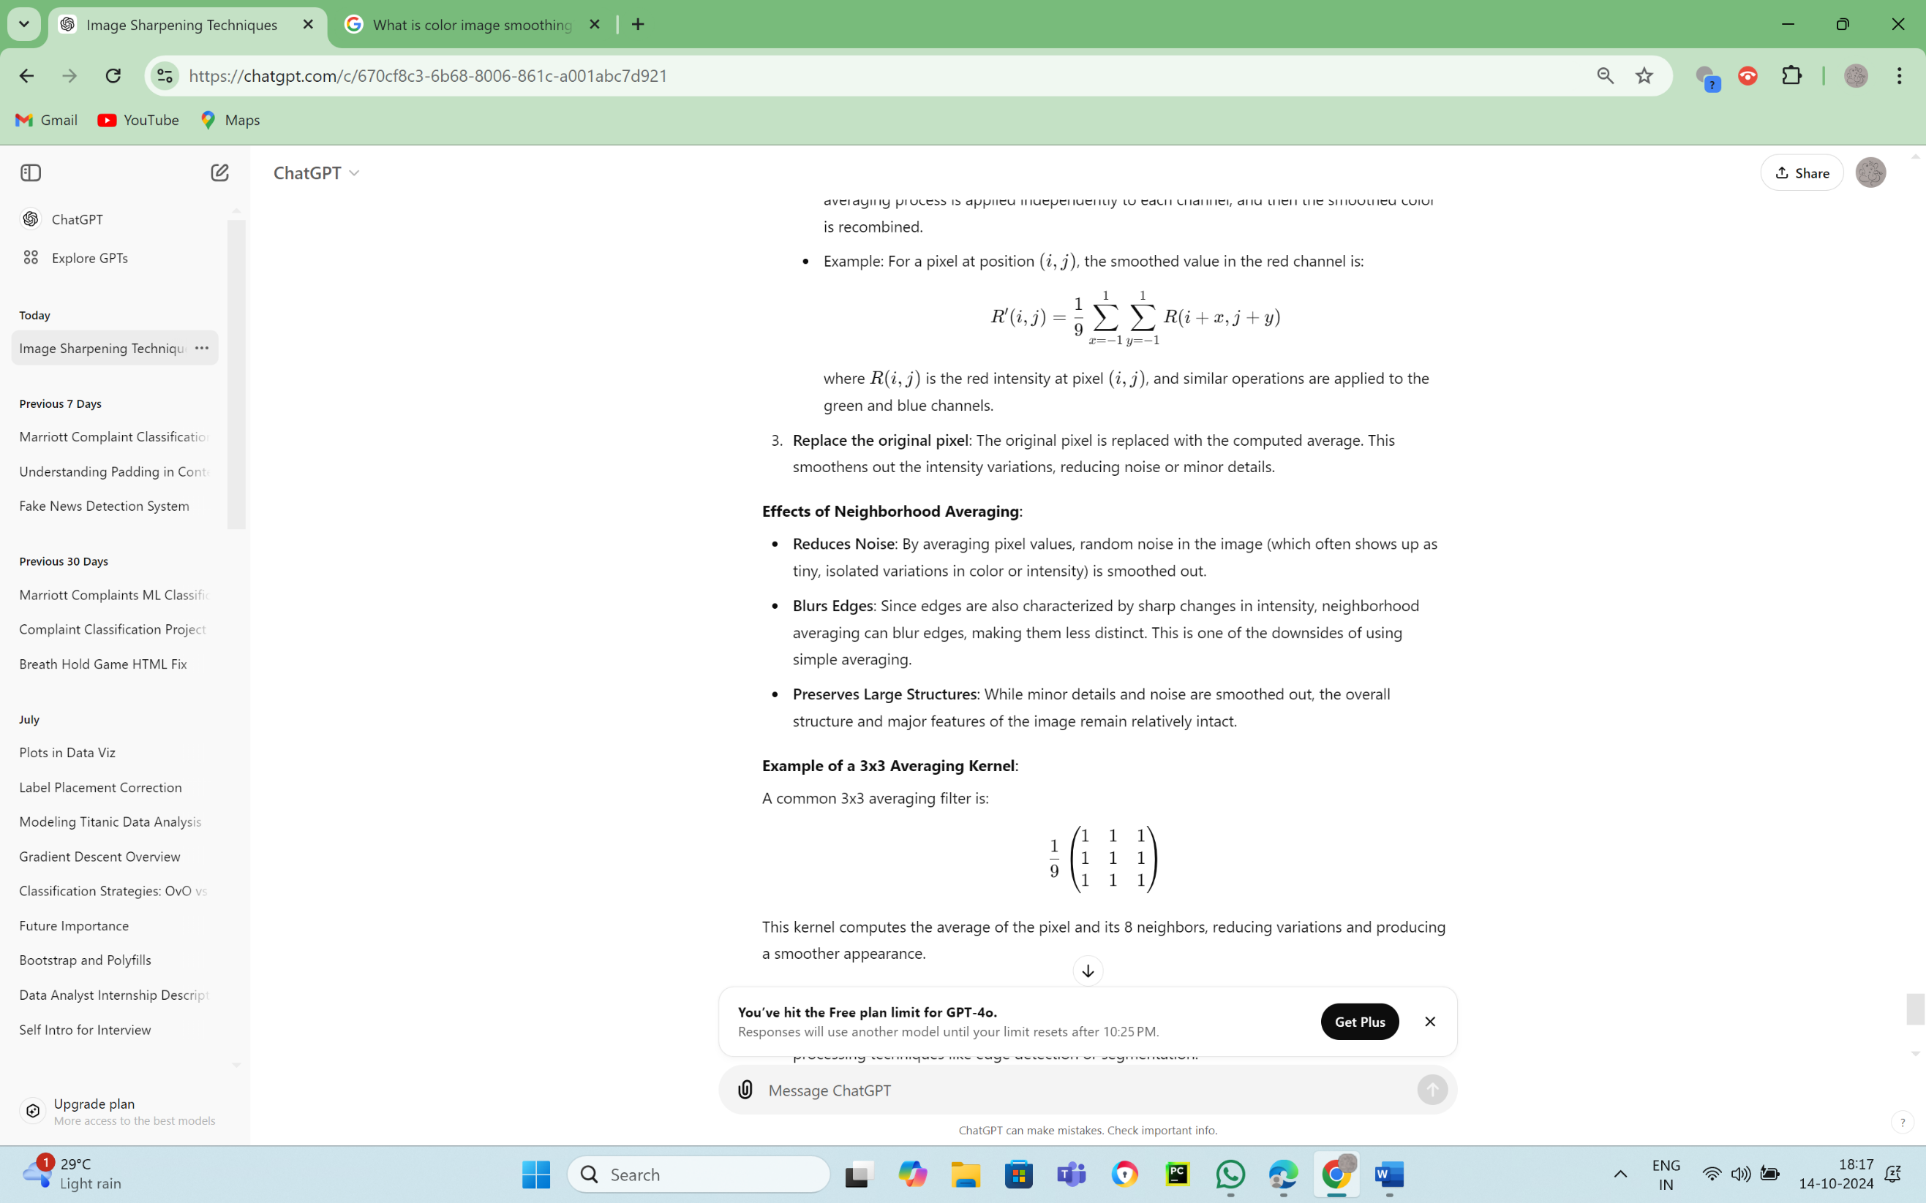

where R(i,j)R(i, j)R(i,j) is the red intensity at pixel (i,j)(i, j)(i,j), and similar operations are applied to the green and blue channels.

1. Replace the original pixel: The original pixel is replaced with the computed average. This smoothens out the intensity variations, reducing noise or minor details.

Effects of Neighborhood Averaging:

* Reduces Noise: By averaging pixel values, random noise in the image (which often shows up as tiny, isolated variations in color or intensity) is smoothed out.
* Blurs Edges: Since edges are also characterized by sharp changes in intensity, neighborhood averaging can blur edges, making them less distinct. This is one of the downsides of using simple averaging.
* Preserves Large Structures: While minor details and noise are smoothed out, the overall structure and major features of the image remain relatively intact.

Example of a 3x3 Averaging Kernel:

A common 3x3 averaging filter is:



This kernel computes the average of the pixel and its 8 neighbors, reducing variations and producing a smoother appearance.

Applications of Color Image Smoothing:

1. Preprocessing: Used as a preprocessing step to remove noise before applying other image processing techniques like edge detection or segmentation.
2. Photography: To soften skin tones or reduce graininess in photos.
3. Medical Imaging: To reduce artifacts or noise in images like CT scans or MRIs, improving clarity for analysis.

**Paper2.6.a) Applications of the RGB Color Model**

The RGB color model is one of the most widely used color models in digital imaging and displays. It is based on the additive color theory, where colors are created by combining different intensities of red, green, and blue light. Here are some common applications of the RGB color model:

1. Digital Displays:
   * Used in computer monitors, television screens, and projectors where colors are created by mixing red, green, and blue light at various intensities.
   * Each pixel on the screen typically consists of sub-pixels for red, green, and blue.
2. Image Editing Software:
   * Most image editing programs (e.g., Adobe Photoshop, GIMP) utilize the RGB color model for editing and manipulating images, allowing users to adjust the intensity of each color channel.
   * Users can create a wide range of colors by manipulating the RGB values.
3. Web Design and Development:
   * The RGB model is the foundation for color selection in web design, where colors are often specified using RGB values or hexadecimal codes in CSS and HTML.
   * Designers use RGB to ensure color consistency across different devices and platforms.
4. Digital Cameras and Imaging Devices:
   * Digital cameras capture images using sensors that translate light into RGB values, allowing for the accurate reproduction of colors in photographs.
   * Post-processing of images often relies on RGB data for adjustments and enhancements.
5. Computer Graphics and Animation:
   * In 3D rendering and animation software, the RGB model is used to define colors for objects and textures, contributing to realistic visual representations.
   * Graphics engines utilize RGB for shading, lighting, and rendering scenes.
6. Medical Imaging:
   * RGB color models are used in certain medical imaging applications to represent and analyze multi-spectral images, such as in dermatology and pathology.

**Paper2.6.b)Histogram Processing of Color Images**

Histogram processing is a fundamental technique in image processing that involves analyzing the distribution of pixel intensities (or colors) to improve the quality and features of an image. In the context of color images, histogram processing can be used to enhance contrast, adjust brightness, and perform various transformations that help in visual analysis and interpretation.

Understanding Histograms

1. Definition: A histogram is a graphical representation of the distribution of pixel intensity values in an image. It displays the number of pixels (frequency) for each possible intensity level (color value).
2. Color Histograms: For a color image, histograms are created for each color channel (typically Red, Green, and Blue). Each channel has its own histogram, which represents the intensity distribution for that specific color.
   * For example, in an 8-bit image, pixel intensity values range from 0 to 255. A histogram for a color image would have three separate plots, one for each channel, showing how many pixels have each intensity value within that channel.

Steps in Histogram Processing of Color Images

1. Histogram Calculation:
   * Compute histograms for each color channel (R, G, and B) by counting the number of pixels for each intensity value from 0 to 255.
2. Histogram Equalization:
   * This is a technique used to improve the contrast of an image. In histogram equalization, the goal is to redistribute pixel intensity values so that the histogram is more uniformly spread over the available intensity range.
   * Process:
     + Calculate the cumulative distribution function (CDF) of the histogram.
     + Use the CDF to map the original intensity values to new values that create a more uniform histogram.
   * Advantages:
     + Enhances the visibility of features in images that have low contrast.
     + Improves overall image quality by utilizing the full range of intensity values.
3. Histogram Specification (Histogram Matching):
   * This technique modifies the histogram of an image to match a desired histogram, typically to achieve a specific visual effect or to enhance the visibility of certain features.
   * Process:
     + Determine the target histogram you want to achieve.
     + Adjust the pixel intensity values of the original image to produce a histogram that closely resembles the target histogram.
4. Contrast Stretching:
   * A simple form of contrast enhancement that linearly stretches the range of intensity values to cover the full dynamic range of the image.
   * Process:
     + Identify the minimum and maximum intensity values in the image.
     + Apply a linear transformation to map the original intensity values to new values that utilize the entire range of available intensities.
   * Advantages:
     + Improves contrast without altering the overall appearance of the image significantly.
5. Individual Channel Processing:
   * When processing color images, techniques can be applied to individual channels to enhance specific colors or to adjust the overall brightness and contrast.
   * For instance, equalizing the histograms of the R, G, and B channels separately can enhance the overall image quality while maintaining color balance. However, care must be taken to avoid color distortion.

Applications of Histogram Processing:

* Image Enhancement: Improves visual quality by enhancing contrast and revealing hidden details in images.
* Object Detection: Helps in segmenting and identifying objects based on their color intensity distributions.
* Medical Imaging: Enhances the visibility of features in medical scans, making it easier to analyze images.
* Facial Recognition: Enhances facial features for better detection and recognition in security systems.